Stainless Steel Electrical Multiple Units (for Sub-Urban operations of Indian Railways)
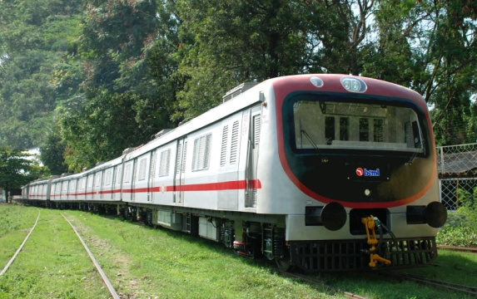
- Aesthetically Designed Interior FRP paneling.
- Windows- Wider horizontal slidingshutter type with toughened glass.
- Polycarbonate moulded seats.
- Compartment illumination with fluorescent light (110 V AC)
- Compartment ventilation – Roof mounted ceiling fans & Forced Air Ventilation Systems.
- Improved design of Strap Hangers, Stainless anti skid floor sheet.
- FRP partition paneling, Aesthetically semi bulkhed gril assembly.
- FRP Cab Mask & Aesthetically designed doors.
- Side wall design – Most modern – Suits fitment of both AC & Non-AC Windows.
- Coupling arrangement – High capacity semi permanent coupling.
Austenitic Stainless steel carbody (except Bolster region)
Track Data | Rail Gauge | 1676mm
 | Minimum  Curve Radius | 175 mtrs
 | Maximum Gradient | 1 in 100
Current  Collection System | Supply Voltage  Current Collection | 25 kV AC  Pantograph
Type of Car | DMC, TC | Driving Motor Coach; Trailer Coach
Basic Specifications
Train Composition | Multiples of 3 Car Unit configurable to 6/9/12/15/18 | DMC-TC-TC
Axle capacity | DMC | 20.32 tonnes
 | TC | 16.25 tonnes
Tare Weight | DMC | 59.30 tonnes
 | TC | 34.00 tonnes
 | Wheel Diameter | 952 mm (New)  877(DMC)/857(TC) mm (fully worn)
Passenger  Carrying Capacity | Seating Standing  Trailer Coach with Vendors Compartment 88 241  Trailer Coach with Ladies Compartment 110 481  Driving Motor Coach 98 264
Speed Control  System  Brake System | Rheostatic Voltage control across full bridge rectifier
Electro Pneumatic Compressed Air Brake with bogie Mounted Brake Cylinder & graduate application & release system.
Tread brake unit with double shoe.
Train Speed | i) Maximum Design Speed 105 kmph
 | ii) Maximum Operation Speed 100 kmph
Car Body  Dimensions in mm | Length over body  Width over body  Height from rail to  top of roof:  Wheel base  Distance between  bogie centers: |  | 20,726  3,658  3,810  2,896  14,630
Bogie & Driving  Gear Unit | - Bogie Type  ii) Suspension  · Primary  · Secondary  iii) Driving Gear Unit |  | Light weight high corrosion resistant Bolstered bogie  Bo’-Bo’ arrangement for motor coach  Steel coil Spring  Air Spring  One Stage Helical Gear with bipartite housing
Propulsion System | Traction Motor |  | DC Series Motor
 | Converter |  | Bridge Rectifier
Insulation | Material: Double side aluminium clad Glass Wool
Floor Covering | Material: Al/SS chequered plate
Customer | Indian Railways
Cars Supplied | 54 Nos. (as on 31-Mar-2017)

