BOBRNAL WAGON

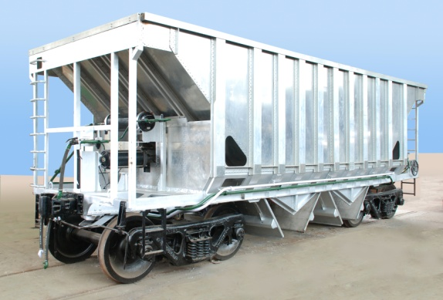
Salient features:
- 3.2 tonne reduction in tare weight
- 3.2 tonne increase in pay lead
- Higher pay lead to tare ratio
- High Speed CASNUB 22 HS Bogie
- Body structure with Huck Bolted
- Aluminium Plates and Extrusions
- Pneumatic operated Bottom Discharge Doors
- Higher corrosion resistance
- Lower maintenance cost due to higher corrosion and abrasion resistance property
- Lighter empty rakes running resulting in reduction in fuel consumption
- No Painting
- Less life cycle cost compared to conventional wagon
- Pneumatic Operated Bottom Discharge doors

General Specification | Gauge : 1676mm  Tare weight : 22.4 Tonnes
Pay Load: 58.88 tonnes
Gross Load : 81.28 tonnes
Dimensions | Length Over Coupling faces : 10600 mm  Overall Width : 3500 mm  Overall Height : 3735 mm  Volumetric Capacity : 56.78 cu.m
Wheel & Axle | Wheel Diameter : 1000mm  Axle Load : 20.32 Tonnes
Brake
Graduated release airbrake system with Jaw type
Slack adjuster and automatic load sensing device to cater for the brake power
Requirement In empty and loaded condition.
Brake
Graduated release airbrake system with Jaw type
Slack adjuster and automatic load sensing device to cater for the brake power
Requirement In empty and loaded condition.
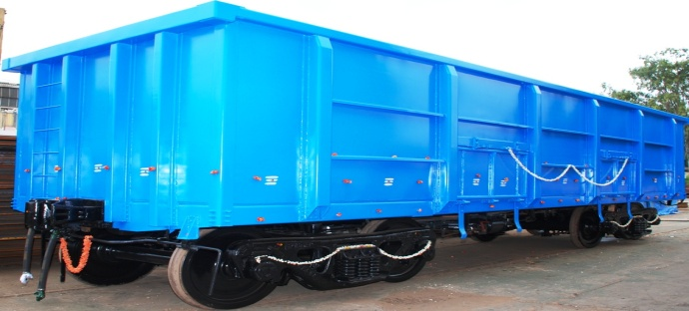
- Reduction in Tare weight & increase in pay Load
- Higher Pay Load to Tare weight Ratio
- Less Corrosion
- Less Fuel consumption in Empty Running
- Throughout Enhancement
- Less incidence of out of course repair
- Reduction in turn around time of Wagon due to fewer detention
- CRF section steel to IRSM;44
General Specification | Gauge : 1676 mm  Tare Weight : 20.52 Tonnes
Pay Load : 71.08 Tonnes
Gross Weight : 91.60 Tonnes
Dimensions | Length Over Coupling Faces : 10963 mm  Overall Width : 3250 mm  Overall Height : 3301 mm  Volumetric Capacity : 61..50 Cu.m  Wheel Diameter : 1000 mm  Axle Load : 22.90 Tonnes
Brake: Graduated Release Air Brake system as per RDSO spec. 02-ABR-2002 & 04-ABR-2002(Latest).
BOXNHL WAGON

