BOXNHL WAGON

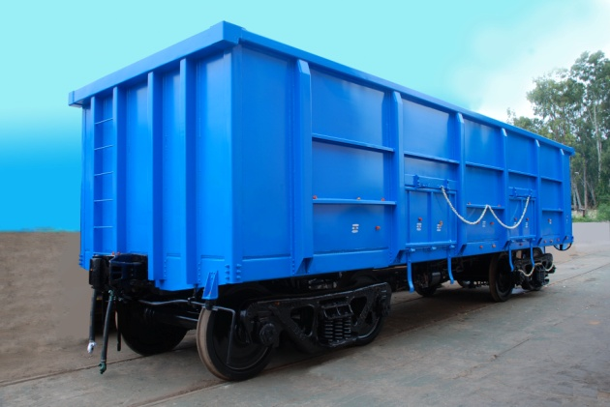
Salient features:
- Reduction in Tare weight & increase in pay Load
- Higher Pay Load to Tare weight Ratio
- Less Corrosion
- Less Fuel consumption in Empty Running
- Throughout Enhancement
- Less incidence of out of course repair
- Reduction in turnaround time of Wagon due to fewer detention
- CRF section steel to IRSM;44
General Specification | Gauge : 1676mm  Tare weight : 20.52 Tonnes
Pay Load : 71.08 Tonnes
Gross Weight : 91.60 Tonnes
Dimensions | Length Over Coupling Faces : 10963 mm  Overall Width : 3250 mm  Overall Height : 3301 mm  Volumetric Capacity : 61..50 Cu.m
Wheel & Axle | Wheel Diameter : 1000mm  Axle Load : 22.90 Tonnes
Brake
Brake: Graduated Release Air Brake system as per RDSO spec. 02-ABR-2002 & 04-ABR-2002(Latest).
Brake
Graduated release airbrake system with Jaw type
Slack adjuster and automatic load sensing device to cater for the brake power
Requirement In empty and loaded condition.
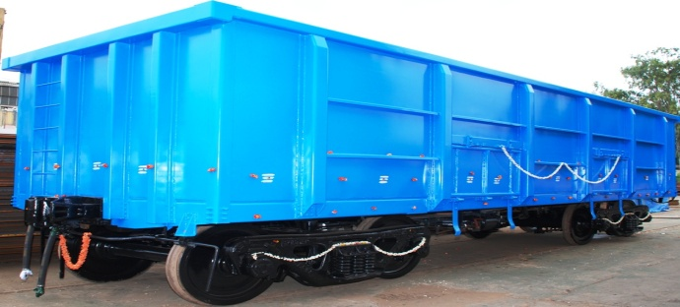
- Reduction in Tare weight & increase in pay Load
- Higher Pay Load to Tare weight Ratio
- Less Corrosion
- Less Fuel consumption in Empty Running
- Throughout Enhancement
- Less incidence of out of course repair
- Reduction in turn around time of Wagon due to fewer detention
- CRF section steel to IRSM;44
General Specification | Gauge : 1676 mm  Tare Weight : 20.52 Tonnes
Pay Load : 71.08 Tonnes
Gross Weight : 91.60 Tonnes
Dimensions | Length Over Coupling Faces : 10963 mm  Overall Width : 3250 mm  Overall Height : 3301 mm  Volumetric Capacity : 61..50 Cu.m  Wheel Diameter : 1000 mm  Axle Load : 22.90 Tonnes
Brake: Graduated Release Air Brake system as per RDSO spec. 02-ABR-2002 & 04-ABR-2002(Latest).
BOXNHL WAGON

